# Master Aero Program

## Purpose and use

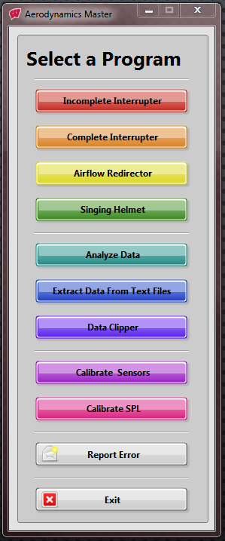The Master Aero program contains all of the collection and analysis programs for our aerodynamic devices. Once opened, the user can select which collection or analysis program they would like to run. The Stand-Alone Calibration program is also accessible through the master program.

The Front Panel is simply an array of different buttons. Each one will open up its corresponding VI through the use of the event handling loop pictured below. Each button is handled by a different case that contains a VI. In the next couple of sections, we will go through each program individually.

The collection programs will be located in the “Collection” section, the analysis programs are in the “Analysis” sections of the Project. The calibration program can be found under “Other”.

There is also an option to run the analysis program separately. To do this, you would run the VI or EXE called Analysis Master.

## Block Diagram

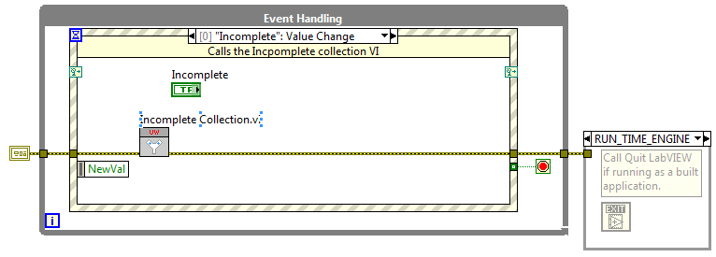This is a simple event structure. It calls a SubVI for each of the buttons that are on the front panel. There are a couple other cases in the event handler that are not directly correlated with buttons on the front panel. Do not worry about these. They simply take care of different exit scenarios. *Do not edit these cases.*